Lucas Madeira Maranho

76990@student.dorset-college.ie

Lecturer: [Meabh Loughman](https://moodle.dorset.ie/user/profile.php?id=3725)

Computer Science – Artificial Intelligence Basics

Group: BSC109224 A

Semester 2

COMPUTER SCIENCE

Assignment 4

Summary

1. - Definition of Multi-Agent Systems (MAS): 2

2.1 - Key characteristics of AI Agent: 3

• Autonomy: 3

• Perception: 3

• Decision-making: 3

• Adaptability: 4

2.2 - Difference between AI Agents and Traditional Software Programs: 4

2.3 – Examples of AI agent and Traditional Software Programs: 5

• AI agent: 5

• Traditional Software program: 5

3. - Multi Agent system X Single agent system: 5

3.1 - Key Differences: 5

• Example of single agent x multi working: 6

4. - Challenges in Multi-Agent Systems: 6

• Coordination and Negotiation Among Agents: 6

• Scalability and Performance Issues: 7

• Agent Behaviour Modelling: 7

5. - References: 10

Part 1:

# 1. - Definition of Multi-Agent Systems (MAS):

Multi-Agent System is a system that involves multiple agents working individually or in groups in the same environment to achieve goals. This agent can be anything, software-based or robots which are able to sense, act focused on their objectives. Each agent has your own knowledge, skill and goals. MAS idea is to identify how agents can work together or compete in solving problems that are hard or improbable to solve with a single agent.

An AI agent, as you see in the image above, it is a software program designed to interact with its environment, perceive the data it receives, and take actions based on it to achieve specific objective. Available at: <https://www.simform.com/blog/ai-agent/>

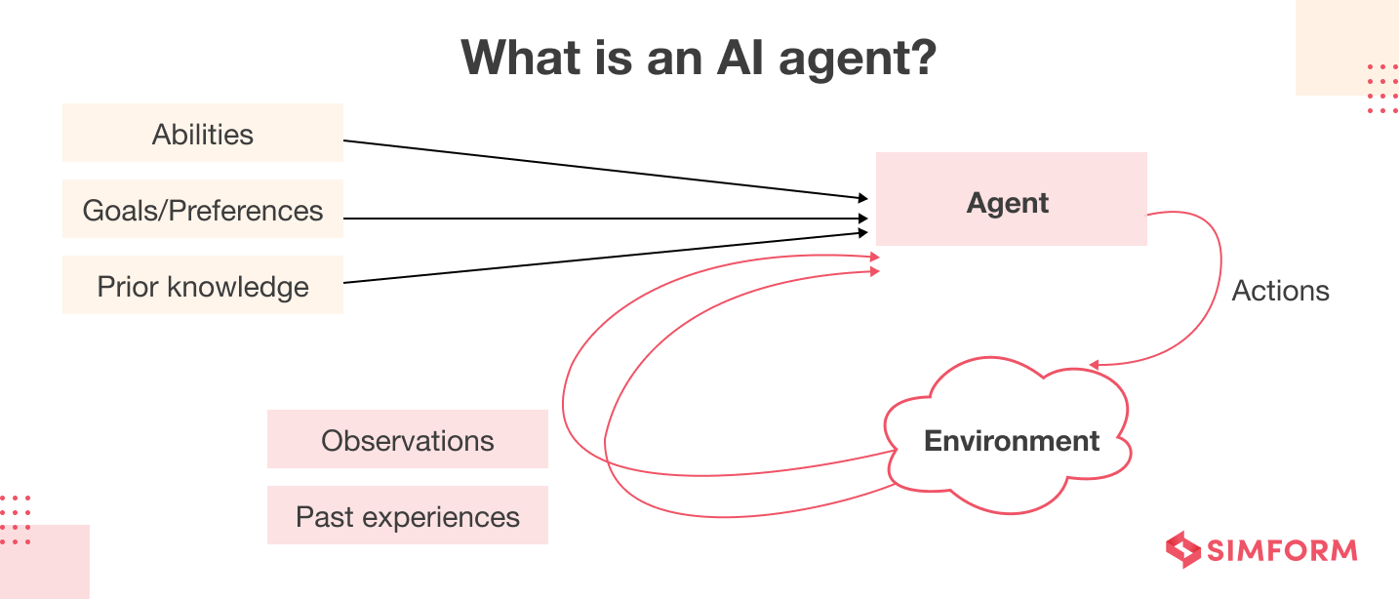

Figure 1 - what is an Ai agent? – (Dhaduk, H. (2025))

Figure 1 is a diagram which contain arrows that show a relationship between AI agent in your environment. AI agent receives input from abilities, goals/preferences and prior knowledge and interact to environment with actions. The environment gives Observation and past experiences which goes to AI agent as a continuous cycle.

# 2.1 - Key characteristics of AI Agent:

* Autonomy:

AI agent doesn’t need continuous human intervention, doing tasks, making decision and adapting to new situations by itself. Many AI agent is improved without hard programming.

* Pros:
* Human workload reduced when dealing with repetitive tasks.
* 24/7 operation
* Cons:
  + Accidental errors.
  + Difficulty with different situations that may occur.
* Perception:

They collect data information from environments with their sensors and with this sensor they can process real-time data to understand patterns.

Because of this real-time data, allows to interact with physical and digital environment.

* Pros:
  + Better ability to interact with environment.
  + Improvement on decision-making by gathering real-time data.
* Cons:
  + Limited if they have poor-quality data.
  + Request high computational power depending on necessity of sensory data.
* Decision-making:

AI agents analyse the data and make decisions based on learning models, they can get instant responses based on rules or being proactive learning from experience.

* Pros:
  + Faster than humans in process datasets.
  + No emotions.
* Cons:
  + Dependents of high training data quality to work well.
  + Some AI can be difficult to interpret.
* Adaptability:

AI agents can improve over time with what they have learned.

* Pros:
  + Improvement without human intervention.
  + Helps AI handle dynamic environments (Improving customer service for example).
* Cons:
  + Requires ongoing data and computational resources.
  + Risks in security.

# 2.2 - Difference between AI Agents and Traditional Software Programs:

|  |  |  |
| --- | --- | --- |
|  | AI Agents | Traditional Software Programs |
| Autonomy | Works independently | Predefined instructions dynamically |
| Perception | Real-time data from sensors | Predefined inputs |
| Decision-making | Increase learning to make choices | Hardcoded rules |
| Adaptability | Improve over time | Static logic |
| Environment | Reacts and acts with environment changes | Fixed parameters |

The table is showing the difference between AI agent and Traditional Software Programs where the autonomy in AI agent works independently while Traditional Software needs to be a predefined instruction.

The perception in AI uses sensors and real-time data to interpret the environment around him, adjusting actions and Traditional Software performance is based on predefined inputs, becoming less flexible in unknown situations.

Decision-making in AI is increased learning models to make better decisions after experiencing some situations.

On the other hand, Traditional Software is executed by hardcode rules which means they can’t learn or improve its original programming.

The adaptability of Traditional Software is static, which means that is necessary manual updates. AI is always improving over time by learning from experiences.

The Traditional Software’s environment is fixed, it doesn’t react with real World, while AI is reactive, changing dynamically.

## 2.3 – Examples of AI agent and Traditional Software Programs:

## AI agent:

Self-driving car, they can avoid accidents making real-time decisions.

Smart Traffic management: It is used to improve the safety and let the traffic flow.

Emergency Response and Ambulance: Coordinating ambulances, hospitals in emergency calls to reduce time to act.

## Traditional Software program:

An example of Traditional software is a calculator which can only be used to do mathematical operations.

# 3. - Multi Agent system X Single agent system:

Basically, speaking a multi-Agent system (MAS) is multiple autonomous agents interacting within a shared environment, where they collaborate and compete to achieve goals while a Single Agent System (SAS) is one agent working in the environment.

# 3.1 - Key Differences:

|  |  |  |
| --- | --- | --- |
|  | Multi-Agent System (MAS) | Single-Agent System (SAS) |
| Quantity of agents | Multiple | One |
| Communication | Communicate and collaborate | Independent |
| Complexity | More difficult, need coordination and competition | Easier, One decision-maker |

Table is to inform the key differences between MAS and SAS.

MAS needs to work with several agents while SAS just need no more than one agent. While SAS operates independently to achieve goals, MAS must work coordinating, collaborating and sometimes competing between them to achieve goals.

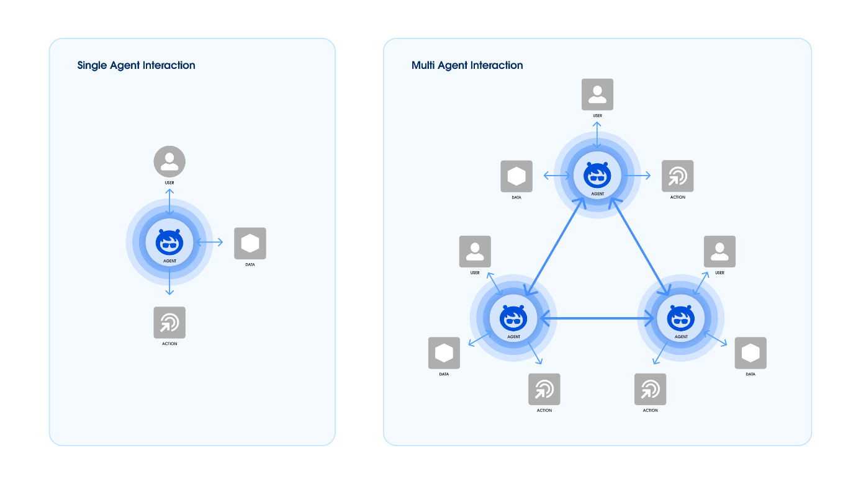

Figure 2 - Single agent x multi agents – Gill, J.K. (2024)

## Example of single agent x multi working:

While a single agent doesn’t need to interact with anybody to achieve goals, the multi-agent needs to coordinate and communicate with each other to finish their tasks.

# 4. - Challenges in Multi-Agent Systems:

* Coordination and Negotiation Among Agents:

Agents in MAS need to interact with each other to achieve individual or the same goals, but to complete these goals are necessary communication, synchronization, negotiation.

Challenges:

Guarantee that the agents agree with the shared goals and separate them with efficient.

Avoid conflicts in multi-agent interactions.

Developing negotiation for competitive environments.

* Scalability and Performance Issues:

With the number of agents in a system increasing, maintain the performance without lose the efficiency is very difficult.

Challenges:

Manage the large amount of agent

Maintain the Real-time efficiency in decision-making and communication

balance system resources to avoid poor performance.

* Agent Behaviour Modelling:

Designing agents that can make decisions by themselves while the conflicts goals is very difficult.

Challenges:

Treat with compensation between goals.

Managing short goals and long goals.

Resolving conflicts because of different priorities.

Conclusion:

Artificial intelligence (AI) agents and Mult-Agent System (MAS) represent a huge evolution, allowing system works autonomously, detecting their environment and make decisions based on information from this environment. Unfortunately, Traditional Software being static and predefined instructions cannot adapt and learn from experiences as AI agents can, making them less effective in dynamic environments.

Single-Agents System (SAS) and Multi-Agent System the main difference between them is the number of agents and their interactions. Single-agent operate with one agent while MAS has to coordinate, collaborate and sometimes compete to achieve goals.

Part 2: Practical situation:

Scenario: Multi-Agent System in a football Simulation:

The scenario simulates a football match with multi-agent system, where agents as autonomous players interact with the field (environment) which the objective is to move the ball to the goal.

1. Environment: Football Field
   * Field is represented as a 7x7 grid.
   * Two goals
     + Top centre row
     + Bot centre row

* Ball starts in the centre of the field.
* 15 rounds steps

1. Agent: Footballers

* 6 players on the field (random position)
* Two teams:
  + Team A
  + Team B
* Autonomous players:
  + Each player moves towards the ball
  + When player reaches the ball, he kick it forward.
  + Ball’s movement is random based on kick.

1. Objective:

* Players competing to control the ball.
* Players from team A must kick the ball towards team B goal and vice versa.
* No goalkeeper or scoring system.
* It’s just to show how players interact with the ball.

1. Player:

* Move to the ball.
* If they reach the ball, they kick.
* Repeat until finish the simulation.

The simple decision-making process real-life positioning and movement:

* Players run after the ball.
* Move it to a goal.
* Ball is disputed.

Conclusion:

This simulation is a MAS where players compete to possess the ball, trying to move it to the ball to the goal using autonomous movement and decision-making.

# 5. - References:

Definition of MAS:

<https://www.simform.com/blog/ai-agent/>

<https://www.salesforce.com/blog/responsibly-manage-multi-agent-systems/>

Key differences:

<https://smythos.com/ai-agents/ai-agent-development/ai-agents-components/>

<https://www.ibm.com/think/topics/ai-agents>